# Plus hydraglyde

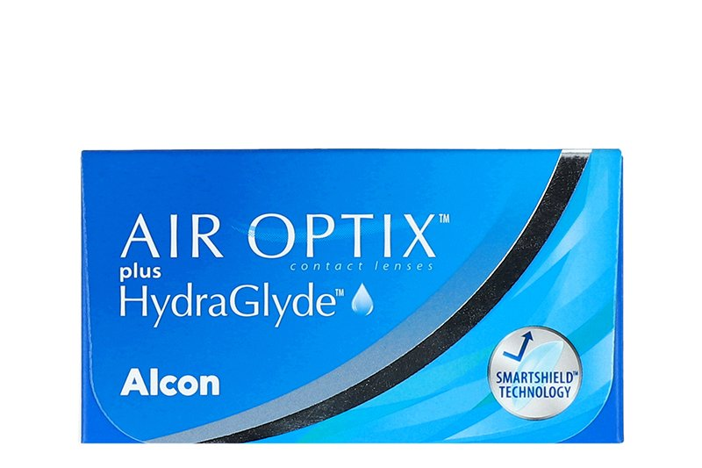

Product information

|  |  |
| --- | --- |
| **Brands** | Air Optix |
| **Availability** | In stoke |
| **Replacement** | 1 month daily wear |
| **Material** | 67% lotrafilcon B, 33% water |

Description

**Air Optix plus HydraGlyde contact lenses are manufactured by Alcon. HydraGlyde technology delivers longer lasting surface wettability to keep the lenses continuously hydrated throughout the day. Additionally, Air Optix plus HydraGlyde contact lenses are designed with SmartShield Technology to maintain wettability and resist lipid deposits throughout the full wearing cycle. The suggested result of the combination of SmartShield and HydraGlyde is a contact lens that creates an ultra-thin protective layer to help shield the contact lenses from irritating deposits and keep the surface moist throughout the day.**